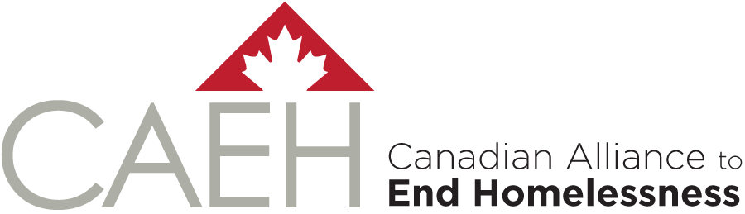

A Pandemic Response and
Recovery Toolkit for Homeless
System Leaders in Canada

Appendix A-4.
Financial Resources for COVID-19: Investments Available for Communities, Agencies and Individuals
Prepared by: OrgCode Consulting, Inc.

June 9, 2020

A-4. Financial Resources for COVID-19: Investments Available for Communities, Agencies and Individuals
The below pan-Canadian funds are currently available to assist community efforts to support vulnerable populations and warrant investigation locally for community leaders. Agencies and community leaders are encouraged to maintain communication with your local funding bodies to receive updates on emerging funding options to support local pandemic response and recovery efforts.

Needs Addressed | Investment | Investment Description
Improving access to essential food support | Organizations such as Food Banks Canada, Salvation Army, Community Food Centres Canada, Second Harvest, and Breakfast Club of Canada will work with local partners to enhance food security issues in communities. Contact your local food bank representatives for details. See announcement here. | $100 million to national, regional and local organizations across Canada to promote the purchase, transportation and safe distribution of food during COVID-19.
Supporting people experiencing homelessness during COVID-19. | Additional support to the homelessness response system has been provided through Reaching Home: Canada’s Homelessness Strategy. | The Government of Canada invested $157.5 million through the national delivery network that is in place under Reaching Home in order to ensure that the homelessness-serving sector has the tools and resources they need to prepare, prevent and manage their response to COVID-19.  The existing Reaching Home directives have also been updated to provide funding recipients with increased flexibility and guidance on how they can use Reaching Home funds to support their COVID-19 response. The funding can be used for a range of needs such as purchasing beds and physical barriers for social distancing and securing accommodation to reduce overcrowding in shelters.
Supporting public health efforts in communities. | Emergency Support for Community Organizations via COVID-19-Novel Coronavirus: Canadian Red Cross Relief and Resources includes such initiatives as:  COVID-19 Emergency Support for Community Organizations Granting Program for Non-Profit  COVID-19 Emergency Support to Community Organizations Preventing Disease Transmission Training and Equipment Program | The Canadian Red Cross is administering federal funds to the non-profit sector to support community-based efforts to meet the essential health, social and economic needs of vulnerable Canadians. These investments will assist in responding to increased demand for vital goods and services; realign service delivery to the COVID-19 reality; improve communication, human resources, etc.  For agencies operating on the frontlines of the COVID-19 response, the Preventing Disease Transmission training will provide the tools to keep clients, staff and volunteers safe.
Social inclusion and well-being needs for vulnerable Canadians. | Canada’s Emergency Community Support Fund is administered through the following national organizations:  United Way Centraide Canada  Canadian Red Cross  Community Foundations of Canada | This $350 million investment supports vulnerable Canadians through non-profit and charitable organizations that deliver essential services to those in need. This investment flows though national organizations that have the ability to get funds quickly to local organizations and is committed to addressing social inclusion or well-being needs of vulnerable Canadians.
Supporting Indigenous Communities in preventing, preparing for and responding to COVID-19. | Indigenous Community Support Fund to assist Indigenous communities | Provision of $380 million for a new fund to address immediate needs in First Nations, Inuit and Metis Nation communities ($305 million) as well as funding to organizations that provide critical services to Indigenous peoples living in urban centres and off-reserve ($75 million). This fund focuses on such activities as supporting elders and vulnerable community members, addresses food insecurity, and preparedness measures for COVID-19.
Supporting women and children fleeing violence | Support provided to over 500 women’s shelters and sexual assault centres, including facilities in Indigenous communities, to help manage and prevent a COVID-19 outbreak in their facilities.  $10 million to Indigenous Services Canada for administration through its Family Prevention Program  $40 million administered by Women and Gender Equity Canada for VAW shelters and sexual assault centres (including $6.46 million for Quebec shelters via Canada-Quebec agreement) | As part of Canada’s COVID-19 Economic Response Plan, the Government of Canada provided an immediate investment of $207.5 million to support organizations serving the most vulnerable populations, including women and children fleeing violence and Canadians experiencing homelessness. This includes:  The $157.5 million to address the needs of Canadians experiencing homelessness through Reaching Home, which can be used to support violence against women’s shelters.  A $40 million investment to women’s shelters and sexual assault centres in order to help with their capacity to manage or prevent an outbreak in their facilities. This funding is being provided to existing organisations, shelters and sexual assault centres across the country.  An investment of $10 million to emergency shelters on reserve and in Yukon to support Indigenous women and children fleeing violence.

